Research Report On: Security Misconfiguration



1. Introduction
Security misconfiguration is one of the most common vulnerabilities that affect web applications, cloud infrastructures, and enterprise systems. It occurs when an application, server, or database is incorrectly configured in a way that exposes it to unnecessary risks. These misconfigurations are often the result of default settings, incomplete configurations, or errors during deployment, which leave the system vulnerable to attacks.

What is Security Misconfiguration?
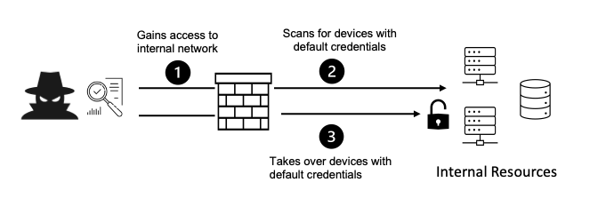
Security misconfiguration happens when security controls are not properly set or are left in their default state, allowing attackers to exploit them. This can happen in any layer of the application stack, from the operating system and web server to the application and database layer.
Misconfigurations could involve:
- Default passwords or weak credentials.
- Unnecessary services left enabled.
- Exposed directories or files with sensitive information.
- Insecure permissions and access control settings.

3. Vulnerabilities Under Security Misconfiguration
Several vulnerabilities fall under the umbrella of security misconfigurations. Some common ones include:
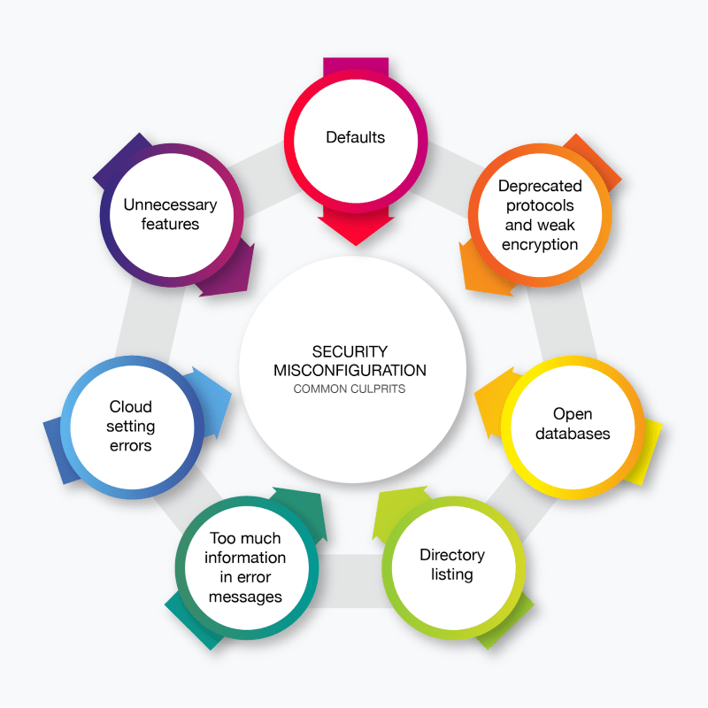
- Default Accounts and Passwords: Leaving default admin accounts or passwords unchanged exposes systems to unauthorized access.
- Exposed Cloud Storage Buckets: Publicly accessible cloud storage can lead to the leak of sensitive data.
- Verbose Error Messages: Detailed error messages may reveal underlying systems and configurations, aiding attackers in launching targeted attacks.
- Unpatched Software: Outdated software can leave known vulnerabilities unaddressed, which hackers can exploit.
- Unnecessary Features or Services: Leaving unused features or services enabled increases the attack surface.

Examples and Case Studies
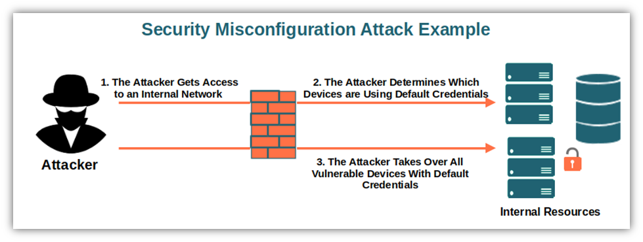
Example 1: Capital One Data Breach (2019) One of the most significant incidents of security misconfiguration occurred with the 2019 Capital One data breach. The company inadvertently exposed sensitive customer data stored in Amazon Web Services (AWS) due to a misconfigured firewall, allowing the attacker to exploit a vulnerability in the cloud infrastructure.

Example 2: Accenture's Exposed Database (2017) Accenture, a global consulting firm, had an exposed cloud server with over 137GB of sensitive data. Due to a misconfiguration, the database was left open without proper security settings, making it accessible to anyone on the internet.

5. Impact of Security Misconfiguration
The impact of security misconfiguration can be severe and wide-ranging, including:
- Data Breaches: Sensitive customer or company data can be exposed, leading to reputational damage and legal consequences.
- Financial Loss: Misconfigurations can lead to financial losses due to cyberattacks, fines, or legal settlements.
- Service Disruption: If critical systems are misconfigured, they can be taken offline, affecting business operations.
- Intellectual Property Theft: Exposed systems might allow attackers to steal proprietary information or trade secrets.

6. Mitigation Measures
To mitigate security misconfigurations, the following measures should be adopted:
- Use of Automated Configuration Management Tools: Automating configurations can reduce human error and ensure proper setup.
- Regular Audits and Reviews: Continuous monitoring of configurations to detect any changes or vulnerabilities.
- Enforcing Strong Authentication: Implementing strong, multi-factor authentication for access to sensitive systems.
- Update and Patch Software Regularly: Ensure that systems, applications, and services are kept up to date.
- Limit and Control Permissions: Apply the principle of least privilege, giving users and services only the access they need.
- Deploy Web Application Firewalls (WAF): A WAF can help mitigate the risks of exposed services and unauthorized access.

7. Conclusion
Security misconfiguration is a critical threat to information security that can have significant consequences if not addressed properly. By following best practices and implementing a proactive approach to security, organizations can reduce the risks associated with misconfigurations and protect their systems from exploitation.

8. References
- OWASP (Open Web Application Security Project). "OWASP Top 10: 2021." https://owasp.org/www-project-top-ten/
- "Capital One Data Breach." https://www.cnbc.com/2019/07/29/capital-one-says-a-hacker-stole-106-million-consumer-records.html
- “Accenture Database Exposed.” https://www.cnbc.com/2017/09/15/accents-exposed-data.html

